Pi Setup



Pi Setup

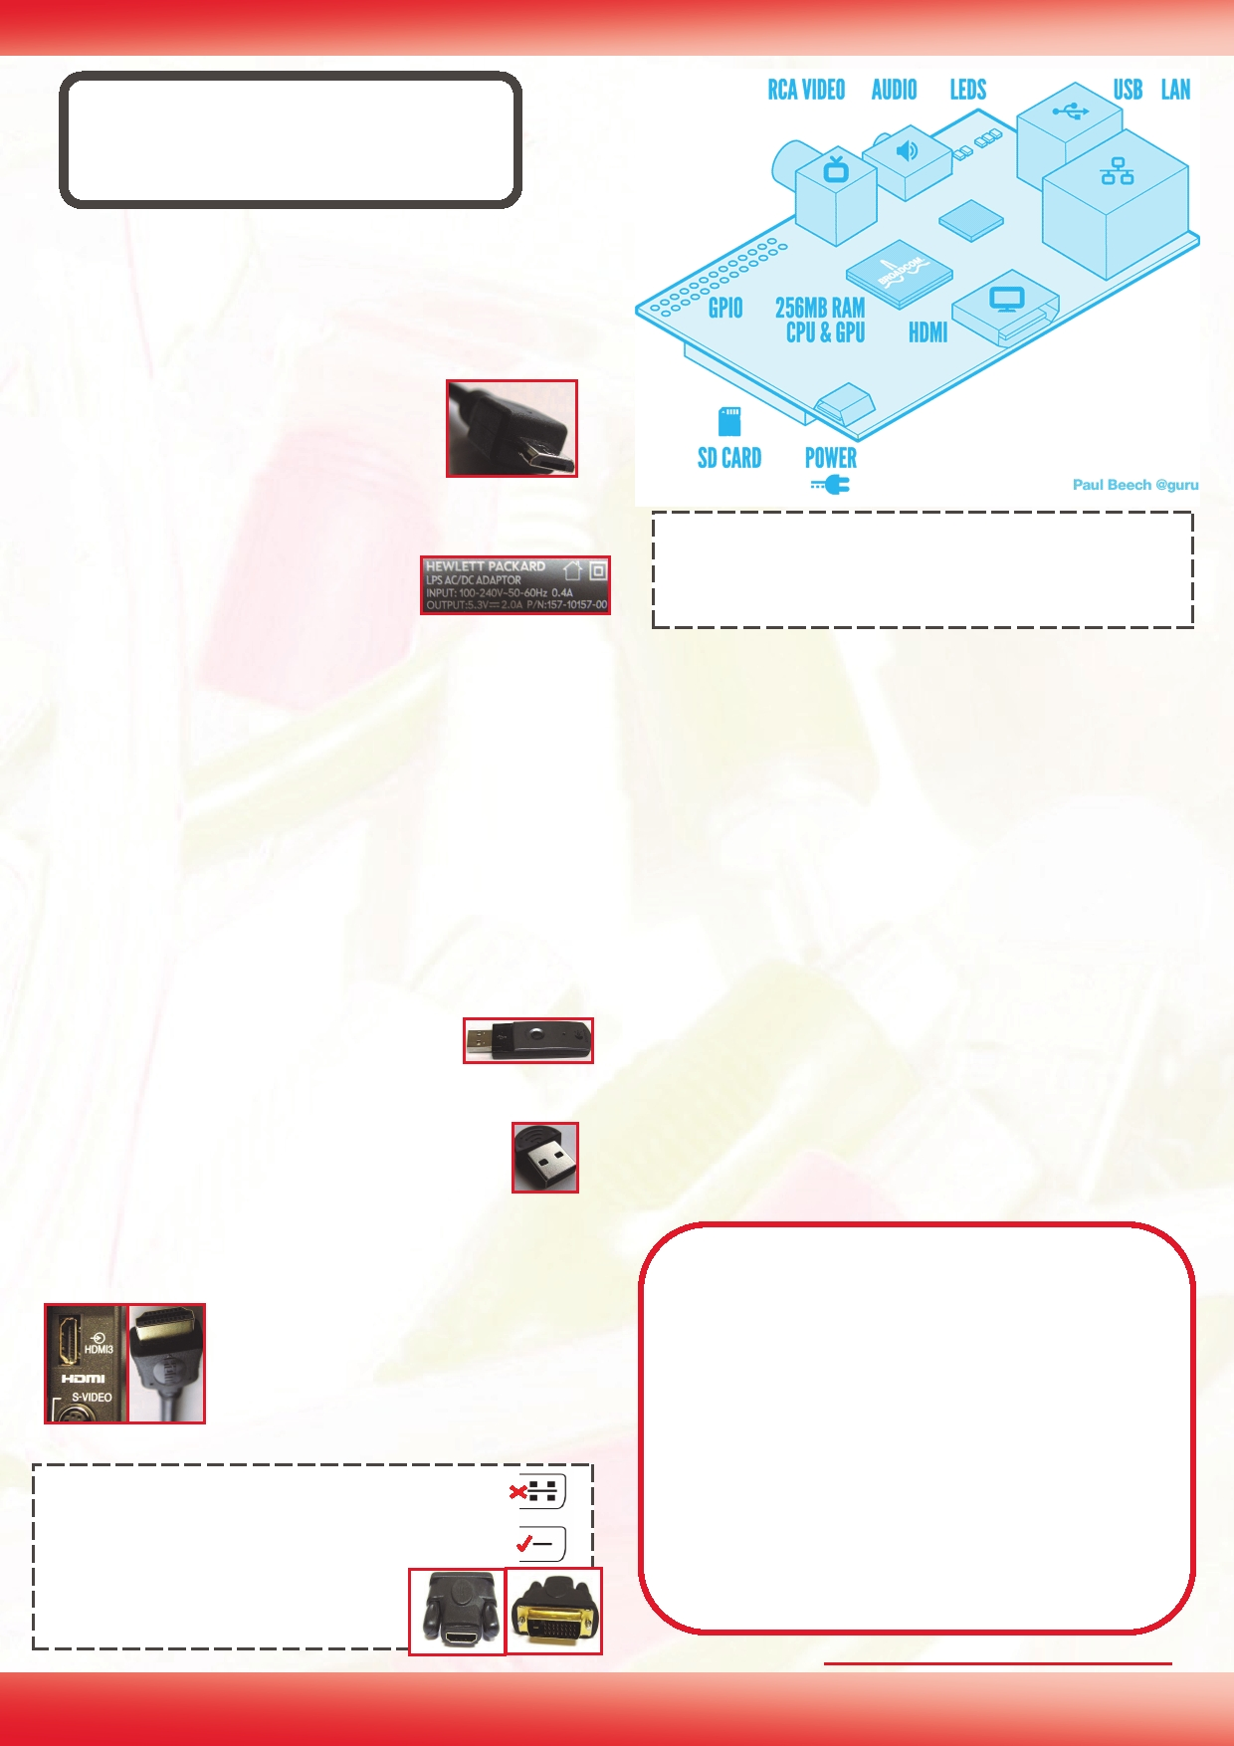

***There are many ways to setup the Raspberry Pi, depending on your needs and the peripherals you wish to use.***

**Power**

The Raspberry Pi uses a micro USB power connector, as used for most

modern smart phones.

The PSU (power supply unit) itself must supply 5V and at least 700mA (0.7A). Most plug in PSUs will be

marked with their specific rating, this one will supply up to 2000mA (2.0A).

**USB**

Micro USB Connector

HP TouchPad PSU

**Tip:** Although most connections can be made while the Raspberry Pi is powered on, it is recommended that the

display and the SD card are only ever connected or discon-

will have a HDMI connection, and newer LCD monitors will often have DVI connections (you will need to use a HDMI to DVI adaptor).

The USB ports on the Raspberry Pi are only suited to low power devices (~100mA), anything which uses too much current will not function correctly. Therefore, a powered USB hub (a USB hub with its own PSU) is recommended, so that all devices will have enough power to operate correctly.

**Control**

Direct control of the Raspberry Pi will be through a mouse and key-

board. This can be with a standard USB Logitech RF Dongle

mouse and keyboard or with a wireless

set using a USB RF dongle. A PS2 keyboard

HDMI to VGA convertors are available but they are

generally expensive (Note: A passive HDMI/DVI to VGA adaptor will not work, as the required analogue signals are not generated by the Raspberry Pi). The analogue RCA output can be used to connect to older TVs, small screens or video capture devices (approximate resolution is 640x480, enough for basic use). If both are attached, the Raspberry Pi will default to HDMI.

**Internet Connection (optional)**

The easiest option is to use a RJ45 wired network cable directly to your router or modem, however with

and mouse will need a USB adaptor, if you tend to use one.

It should also be possible to use a Bluetooth Bluetooth

keyboard and mouse, using a low cost

in-

some additional setup it may be possible to connect

to your Wifi network by using a USB dongle.

Bluetooth USB adaptor, but some additional setup will

be required.

**Display**

Your display will depend on what you

**Basic Equipment**

1. Micro USB Charger (rated at 5V 700mA

minimum), plus micro USB cable if needed.

2. SD Card (2Gb up to SDHC 32Gb), plus suitable

TV HDMI Connection

have available to you, most digital TVs

card reader.

3. HDMI Cable/Suitable cable for display

**HDMI to DVI Adaptor/Cables:**

Ensure your DVI connections match as there are several types. Many monitors will only support DVI-D (bottom) with no holes for the four analogue pins DVI-

A/DVI-I (top), so an DVI-D adaptor is recommended (this will also fit monitors with DVI-A/DVI-I support).

HDMI to DVI-D Adap-

tor

**4**

4. Compatible Mouse/Keyboard

5. Powered USB Hub (required for high powered

USB devices)

Recommended HW see:<http://elinux.org/RPi_VerifiedPeripherals>

**The MagPi Issue 02 June 2012**

***Example Hardware Setups***

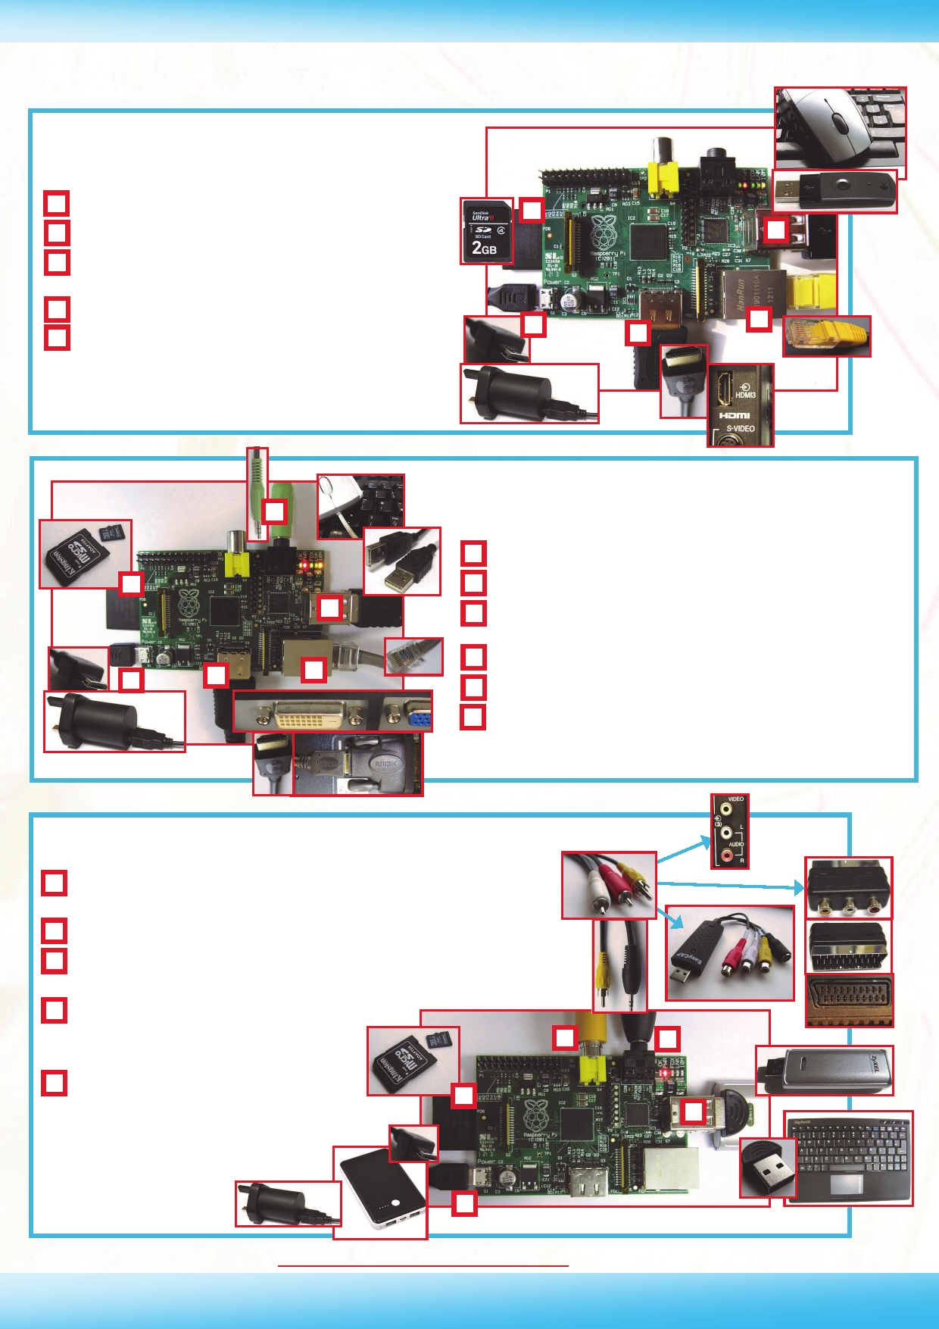

**HDTV Setup**

**A**

**BC**

**D**

**E**

**Power :** Micro USB Charger

**SD Card :** Standard Size SD Card

**HDMI :** Connected to HD TV HDMI input for

1080p & digital audio

**LAN :** Wire connection to network hub/switch **USB :** Wireless RF Dongle for Mouse and Key-

**B**

**A**

**C**

**D**

**E**

board

**B**

**A**

**C**

**F**

**D**

**E**

**A**

**B**

**C**

**D**

**E**

**LCD Monitor Setup**

**Power :** Micro USB Charger

**SD Card :** Micro SD card with Full Size Adaptor

**HDMI :** Connected to HDMI to DVI-D adaptor, then

into monitor DVI input for 1080p (no audio)

**LAN :** Wire connection to network hub/switch

**USB :** USB Mouse and USB Keyboard

**Video Out Setup**

**F**

**Audio :** 3.5mm Audio out to speakers/headphones

**A**

**B**

**C**

**D**

**Power :** Micro USB Charger / High Capacity Mobile Battery

(rated output at 5V 700mA or more)

**SD Card :** Micro SD card with Full Size Adaptor

**RCA Video :** Connected to either TV AV In/SCART adaptor

(European-TV connection)/USB Video Capture Device

**Audio :** 3.5mm Audio Jack to Phono

connections allows audio to be connected along with the video

**C**

**D**

**E**

**USB :** Bluetooth Dongle for connec-

tion to Bluetooth Keyboard/Mouse, Wifi

Dongle for wireless connection to network (probably powered

USB Hub and

additional setup

**B**

**A**

**E**

More information see the Wiki Pages:<http://elinux.org/RPi_Hardware_Basic_Setup> **Article by Meltwater**

**5**

PiSection — Trek



PiSetup — Concourse

**{xx}**  **The MagPi Issue 02 June 2012**



**{xx}**

